Deploying GKE Autopilot Clusters
experimentLabschedule1 houruniversal_currency_altNo costshow_chartIntroductory
infoThis lab may incorporate AI tools to support your learning.

Overview
In this lab, you use the Google Cloud console to build GKE Autopilot clusters and deploy a sample Pod.

Objectives
In this lab, you learn how to perform the following tasks:
- Use the Google Cloud console to build and manipulate GKE Autopilot clusters
- Use the Google Cloud console to deploy a Pod
- Use the Google Cloud console to examine the cluster and Pods

Lab setup
For each lab, you get a new Google Cloud project and set of resources for a fixed time at no cost.
- Click the Start Lab button. If you need to pay for the lab, a pop-up opens for you to select your payment method. On the left is the Lab Details panel with the following:
  - The Open Google Cloud console button
  - Time remaining
  - The temporary credentials that you must use for this lab
  - Other information, if needed, to step through this lab
- Click Open Google Cloud console (or right-click and select Open Link in Incognito Window if you are running the Chrome browser).
The lab spins up resources, and then opens another tab that shows the Sign in page.
Tip: Arrange the tabs in separate windows, side-by-side.
- Note: If you see the Choose an account dialog, click Use Another Account.
- If necessary, copy the Username below and paste it into the Sign in dialog.
- "Username"
- Copied!
- You can also find the Username in the Lab Details panel.
- Click Next.
- Copy the Password below and paste it into the Welcome dialog.
- "Password"
- Copied!
- You can also find the Password in the Lab Details panel.
- Click Next.
- Important: You must use the credentials the lab provides you. Do not use your Google Cloud account credentials.
- Note: Using your own Google Cloud account for this lab may incur extra charges.
- Click through the subsequent pages:
  - Accept the terms and conditions.
  - Do not add recovery options or two-factor authentication (because this is a temporary account).
  - Do not sign up for free trials.
After a few moments, the Google Cloud console opens in this tab.
Note: To view a menu with a list of Google Cloud products and services, click the Navigation menu at the top-left, or type the service or product name in the Search field. 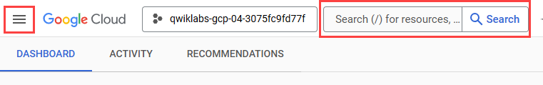
After you complete the initial sign-in steps, the project dashboard opens.

Task 1. Deploy GKE clusters
In this task, you use the Google Cloud console and Cloud Shell to deploy GKE clusters.

Use the Google Cloud console to deploy a GKE cluster
- In the Google Cloud console, in the Navigation menu (), click Kubernetes Engine > Clusters.
- Click Create to begin creating a GKE cluster.
A pop-up titled Welcome to the new cluster creator appears. Click Let's get started to proceed.
- Examine the console UI and the controls to change the cluster name, the cluster location, the Kubernetes version, the number of nodes, and the node resources such as the machine type in the default node pool.
Clusters can be created across a region or in a single zone. A single zone is the default. When you deploy across a region the nodes are deployed to three separate zones and the total number of nodes deployed will be three times higher.
- Change the cluster name to autopilot-cluster-1 and region to REGION. Leave all the values at their defaults and click Create.
The cluster begins provisioning.
Note: You need to wait several minutes (up to 15 minutes) for the cluster deployment to complete.
When provisioning is complete, the Kubernetes Engine > Clusters page looks like this screenshot:
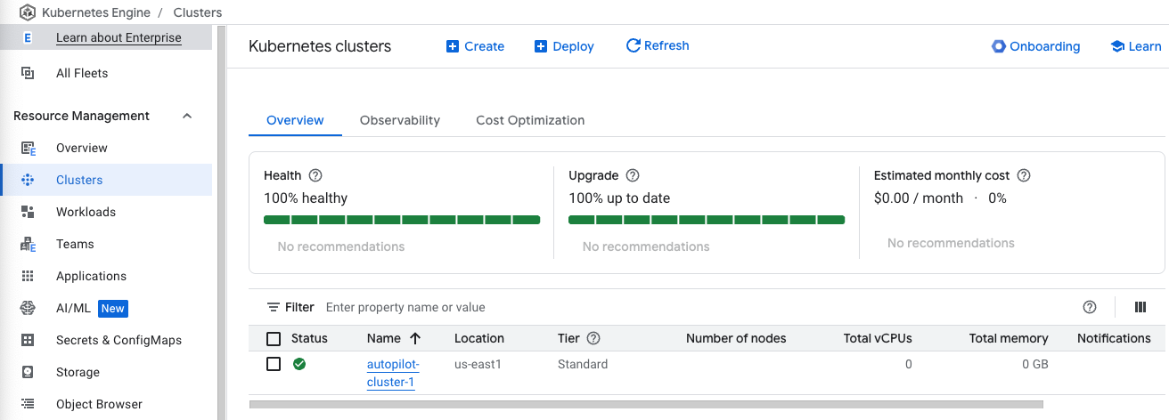
Click Check my progress to verify the objective.
Deploy GKE cluster
- Click the cluster name autopilot-cluster-1 to view the cluster details.
- You can scroll down the page to view more details.
- Click the Storage tab at the top to view more of the cluster details.

Task 2. Deploy a sample workload
In this task, you will use the Google Cloud console to deploy a Pod running the nginx web server as a sample workload.
- In the Google Cloud console, in the Navigation menu(), click Kubernetes Engine > Workloads.
- Click Creat deployment.
- For Deployment name enter nginx-1.
Accept the default container image, nginx:latest, which deploys three Pods each with a single container running the latest version of nginx.
- Click the Deploy button, leaving the Configuration details at the defaults.
- When the deployment completes your screen will refresh to show the details of your new nginx deployment.
Click Check my progress to verify the objective.
Deploy a sample nginx workload

Task 3. View details about workloads in the Google Cloud console
In this task, you view details about your GKE workloads directly in the Google Cloud console.
- In the Google Cloud Console, navigate to Kubernetes Engine > Workloads page and click nginx-1.
This displays the overview information for the workload, showing details like resource utilization charts, links to logs, and details of the Pods associated with this workload.
- In the Google Cloud console, click the Details tab for the nginx-1 workload. The Details tab shows more details about the workload including the Pod specification, number and status of Pod replicas, and details about the horizontal Pod autoscaler.
- Click the Revision History tab. This displays a list of the revisions that have been made to this workload.
- Click the Events tab. This tab lists events associated with this workload.
- Then, click the YAML tab. This tab provides the complete YAML file that defines these components and full configuration of this sample workload.
- While you are still in the Google Cloud console's Details tab for the nginx-1 workload, click the Overview tab, scroll down to the Managed Pods section, and click the name of one of the Pods to view the details page for that Pod.
- The Pod details page provides information on the Pod configuration and resource utilization and the node where the Pod is running.
- In the Pod details page, you can click the Events and Logs tabs to view event details and links to container logs in Cloud Operations.
- Click the YAML tab to view the detailed YAML file for the Pod configuration.

End your lab
When you have completed your lab, click End Lab. Google Skills removes the resources you’ve used and cleans the account for you.
You will be given an opportunity to rate the lab experience. Select the applicable number of stars, type a comment, and then click Submit.
The number of stars indicates the following:
- 1 star = Very dissatisfied
- 2 stars = Dissatisfied
- 3 stars = Neutral
- 4 stars = Satisfied
- 5 stars = Very satisfied
You can close the dialog box if you don't want to provide feedback.
For feedback, suggestions, or corrections, please use the Support tab.
Copyright 2026 Google LLC All rights reserved. Google and the Google logo are trademarks of Google LLC. All other company and product names may be trademarks of the respective companies with which they are associated.

